**Automated Water Level monitoring system using**

**PIC Microcontroller**

**22ECC51-Embedded System and IoT**

**A Mini Project Report**

**Submitted by**

**AYISHA A(22ECR030)**

**DHARSANA A(22ECR045)**

**DHARSHAN S(22ECR046)**

**DEPARTMENT OF ELECTRONICS AND COMMUNICATION ENGINEERING**



**KONGU ENGINEERING COLLEGE**

**PERUNDURAI-638060**

**Nov-2024**

**ABSTRACT**

This project focuses on developing a cost-effective, sensorless automated water level monitoring system using the PIC16F877A microcontroller. Traditional water level sensing often requires float or ultrasonic sensors, which can add to costs and complexity. In contrast, this design capitalizes on the conductivity of water to determine level status without the need for dedicated sensors. Multiple conductive wires are placed at pre-set heights within a water tank, each representing a specific water level. As water reaches these wires, a conductive circuit is established, sending an electrical signal to the microcontroller. The PIC16F877A processes these signals to monitor real-time water levels, which can then be used to control pumps, alarms, or display systems. This approach not only reduces hardware costs but also enhances durability by minimizing mechanical parts. This system offers a versatile solution suitable for household water tanks, agricultural irrigation setups, and industrial water management, promoting resource conservation through automated water control.

**TABLE OF CONTENTS**

|  |  |  |
| --- | --- | --- |
| **CHAPTER**  **NO** | **CONTENT** | **PAGE NO** |
| 1 | INTRODUCTION |  |
| 2 | METHODOLOGY |  |
| 3 | RESULT AND DISCUSSION |  |
| 4 | CONCLUTION |  |

**CHAPTER 1**

**INTRODUCTION**

Effective water level monitoring is an essential aspect of resource management in a wide range of applications, from residential water tanks and agricultural irrigation systems to industrial storage and environmental management. Traditional water level monitoring solutions typically rely on mechanical float sensors or electronic sensors, such as ultrasonic or capacitive sensors, to measure water levels accurately. However, these methods come with several limitations, including high costs, maintenance requirements, and susceptibility to wear and tear over time. This project introduces an innovative, cost-effective alternative: a sensorless water level monitoring system using the PIC16F877A microcontroller. By utilizing water's natural conductivity properties, this approach eliminates the need for dedicated sensors, making the system both economical and easy to implement.

The fundamental concept behind this project is to use conductive wires positioned at various heights within the water tank to detect water levels. As water rises to reach each wire, it completes a circuit, which is then registered as a signal by the PIC16F877A microcontroller. Each level in the tank corresponds to a specific wire, allowing the system to determine the exact water level based on which circuits are complete. The PIC16F877A processes these signals to generate a real-time indication of the water level, enabling the system to communicate the status visually, audibly, such as activating a pump or an alarm. This design can be customized to meet the specific needs of the user, with the option to increase or decrease the number of levels detected by adjusting the number of wires.

This sensorless approach offers several advantages. First, it significantly reduces the overall cost by removing the need for specialized water level sensors. Second, it is more robust and durable, as there are fewer mechanical components that could fail or require regular maintenance. Additionally, by using an embedded microcontroller, the system can be easily integrated into larger automated setups, allowing for precise control over water usage, filling, and drainage cycles. This feature is especially beneficial for applications requiring regular water management, such as in agricultural fields where efficient water use is essential, or in industrial environments where strict water level regulation is necessary.

**CHAPTER – 2**

**METHODOLOGY**

The automated water level monitoring system operates based on water conductivity and utilizes a PIC16F877A microcontroller as its main control unit. The system begins with a +5V DC power supply, which powers the microcontroller and other components, while a crystal oscillator provides a stable clock frequency for the PIC16F877A, ensuring consistent performance. Conductive wires are placed at various heights within the water tank to serve as level indicators. When water reaches a specific height, it completes a circuit with the corresponding wire, signaling to the microcontroller that the water level has reached that point.

The microcontroller is programmed to interpret these signals and display the current water level (e.g., "Low," "Medium," "High") on an LCD screen. The LCD is connected to the microcontroller and provides real-time feedback on water levels, allowing users to monitor the tank easily. Additionally, the LCD shows the pump’s operational status (ON/OFF), enhancing user awareness of system activity. A variable resistor is used to adjust the LCD contrast for better readability, ensuring that the displayed information is clear under different lighting conditions.

To control the water pump, the system incorporates a relay circuit connected to the microcontroller. When the water level drops to a "Low" status, the microcontroller activates a transistor, which in turn energizes the relay and switches on the pump to refill the tank. A protective diode is included to safeguard the relay circuit from voltage spikes during switching. When the water level reaches the "High" mark, the microcontroller deactivates the pump, conserving water and preventing overflow. This design offers an efficient, low-maintenance solution for water level monitoring and management across various applications, from households to industrial setups.

**CHAPTER – 3**

**RESULT AND DISCUSSION**

1. **Simulation Output**

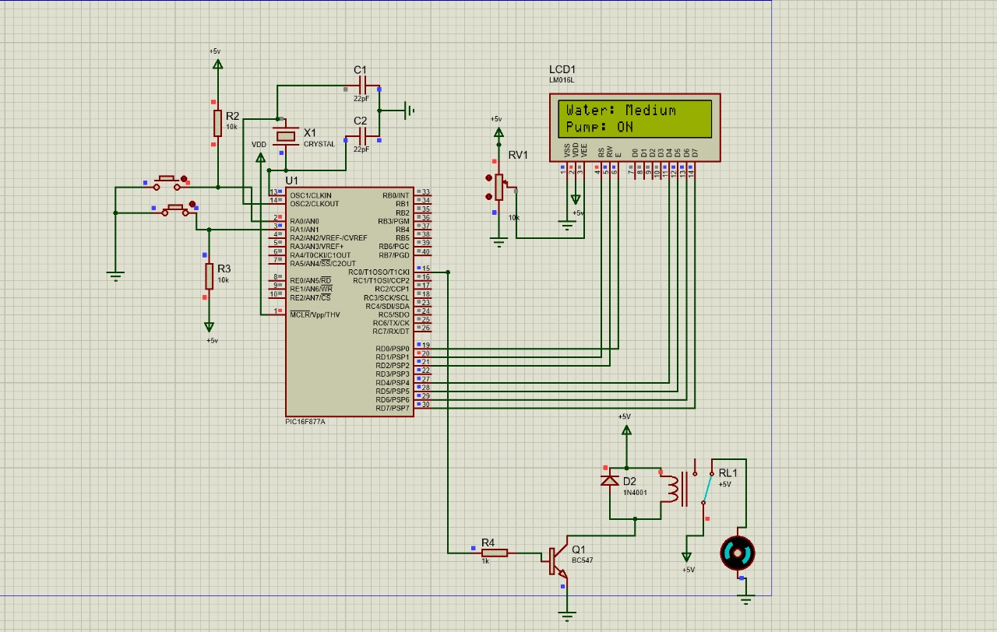

1. **Hardware Output**

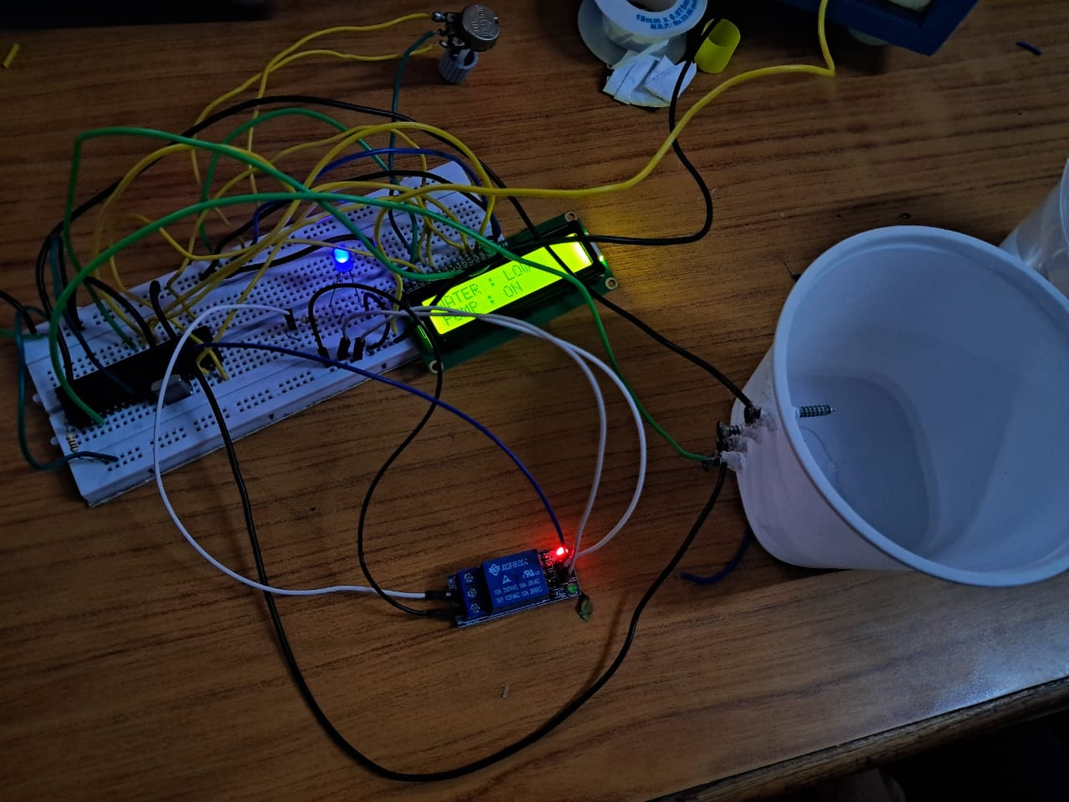

1. **Video link**



**CONCLUSION**

In conclusion, this automated water level monitoring system using the PIC16F877A microcontroller provides an efficient, low-cost, and reliable solution for water management. By utilizing water's conductivity to detect levels without traditional sensors, the system reduces hardware complexity and maintenance needs. The microcontroller’s integration with an LCD display allows for clear real-time monitoring of water levels and pump status, while the relay-controlled pump ensures automatic filling based on water demand. This sensorless design is adaptable for use in household, agricultural, and industrial applications, offering a sustainable approach to water conservation and automated control.